**Arithmetic calculator**

Source Code:

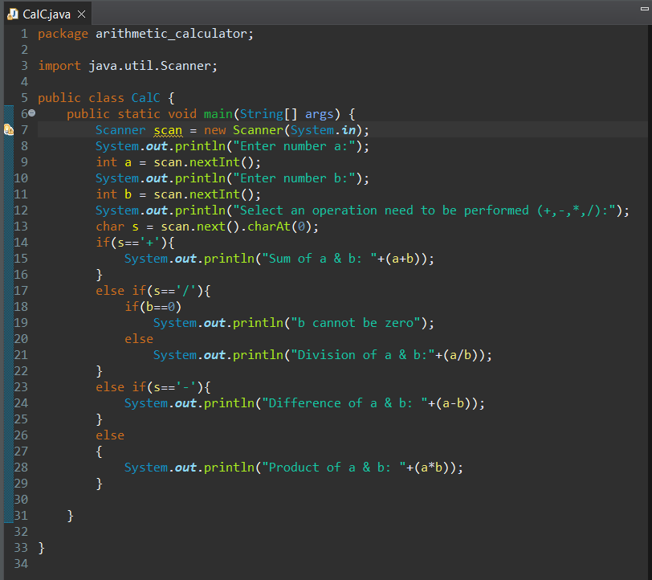

Output:

